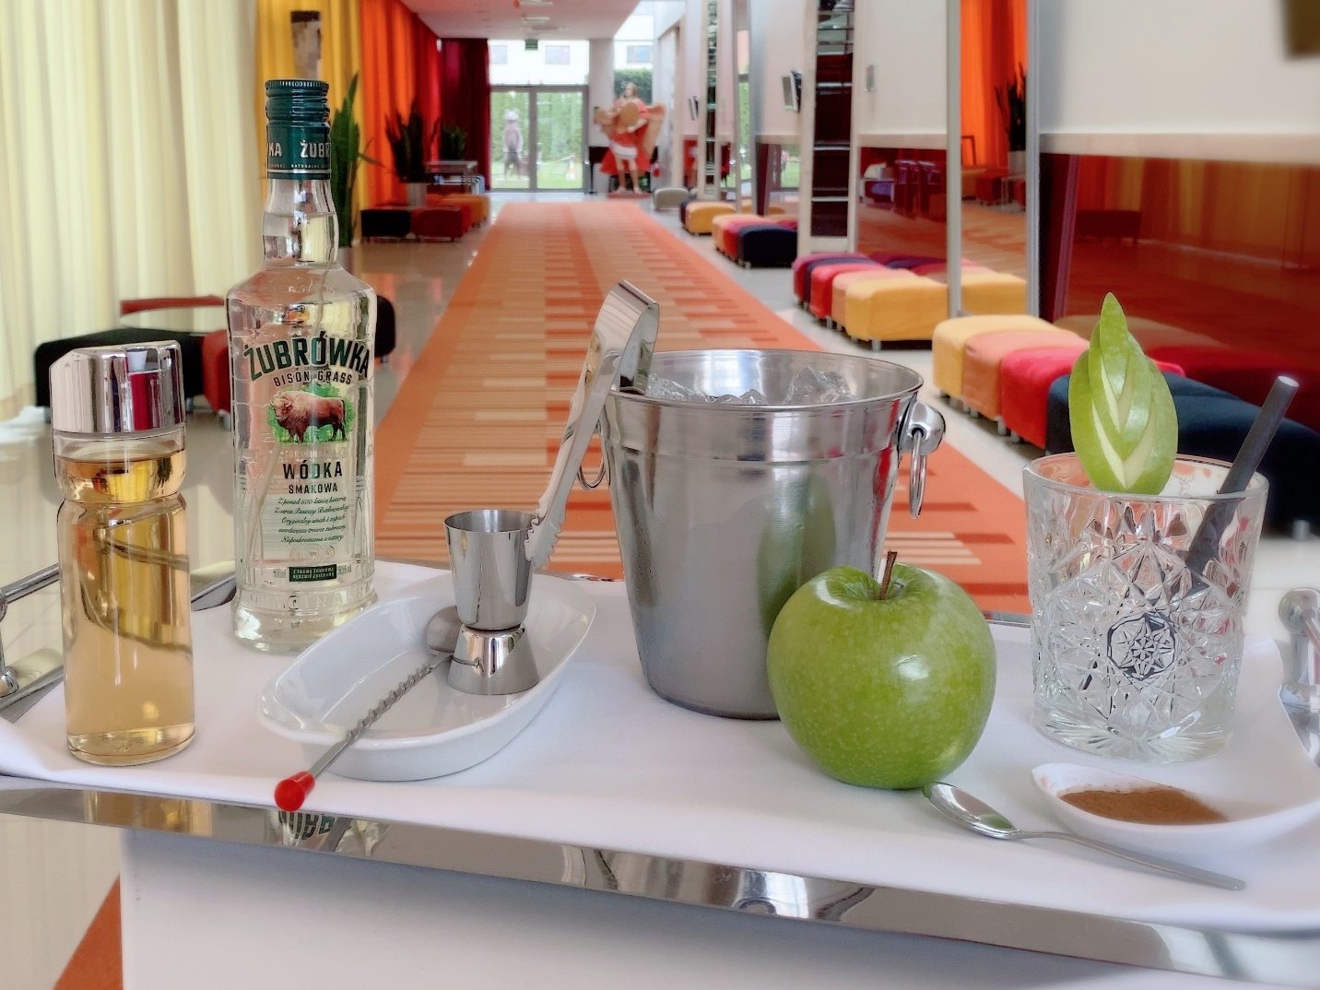

Żubrówka Bison Grass is an iconic Polish flavored vodka produced from top quality grain and tincture of bison grass. In every bottle of Żubrówka Bison Grass, a blade of grass is placed for decoration and to highlight the natural origin of the unmatched flavor. Szarlotka (Apple Pie) is the name of the Polish cocktail, which is made from almost the same ingredients as the real apple pie. The third ingredient that makes those two completely different is Żubrówka (Bison Grass Vodka). Żubrowka is the world’s best-known Polish vodka, with more than 500 years of tradition and history.
Szarlotka cocktail:
- 2/3 chilled apple juice
- 1/3 ice cold Żubrówka
- a pinch of ground cinnamon
- extra ice cubes

