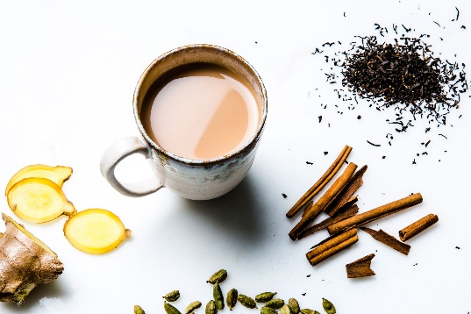
Masala Tea is a flavored tea made by brewing black tea with a mixture of aromatic Indian spices and herbs. Originating in the Indian subcontinent, the beverage has gained worldwide popularity, becoming a feature in many coffee and tea houses.
It is one of the favorite drinks among Indians especially during the monsoon and cold winters. It is believed that it keeps the body warm and breaks up the blocked sinus. A large population drink it around the year along with their breakfast and evening snacks.
Recipe:
Ingredients:
2 cups of water
1 cup of milk
3 pieces of cloves
2 pieces of cardamom
Sugar (as per taste)
4 seeds of black pepper
Tea leaves
Ginger (grated)

Directions:
1) Add two cups of water in a pan and let it boil, then add grated ginger to the same.
2) Then, add 2 pieces of cardamom, 3 pieces of cloves, a few black pepper seeds and wait for it to boil for about 3-4 minutes.
3) Now, add 2 spoons of tea leaves to the pan followed by sugar according to your preference. After this, add one cup of milk to the pan and let it boil.
4) Finally, strain the tea into your favorite cup and serve it with some tasty cookies or Indian bhajiya.

