Maltese Hobz biz-zejt
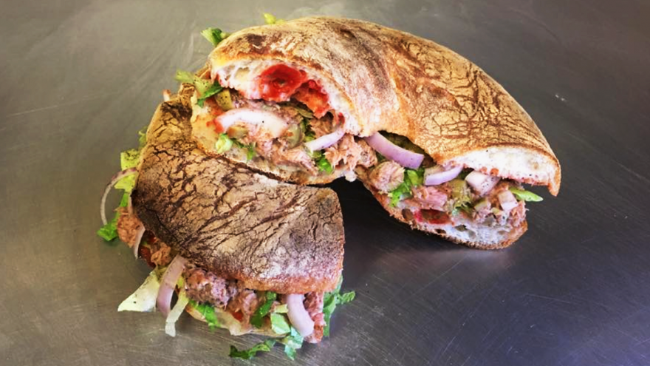

Our Traditional Hobz biz-zejt (translation ‘Bread with Oil’) uses ‘Ftira’ Bread however, since this is not easily found outside Malta and Gozo, you can use a Ciabatta Style bread instead, which will work just as well.
Start off by slicing the loaf in half pour olive oil on it and spreadwith ‘kunserva’ (Tomato paste). Fillings can vary but traditionally would include olives, sliced raw onions, tomatoes, capers, canned tuna and parsley. Finally, add a another generous drizzle of olive oil and a sprinkle of salt and pepper to finish off.

