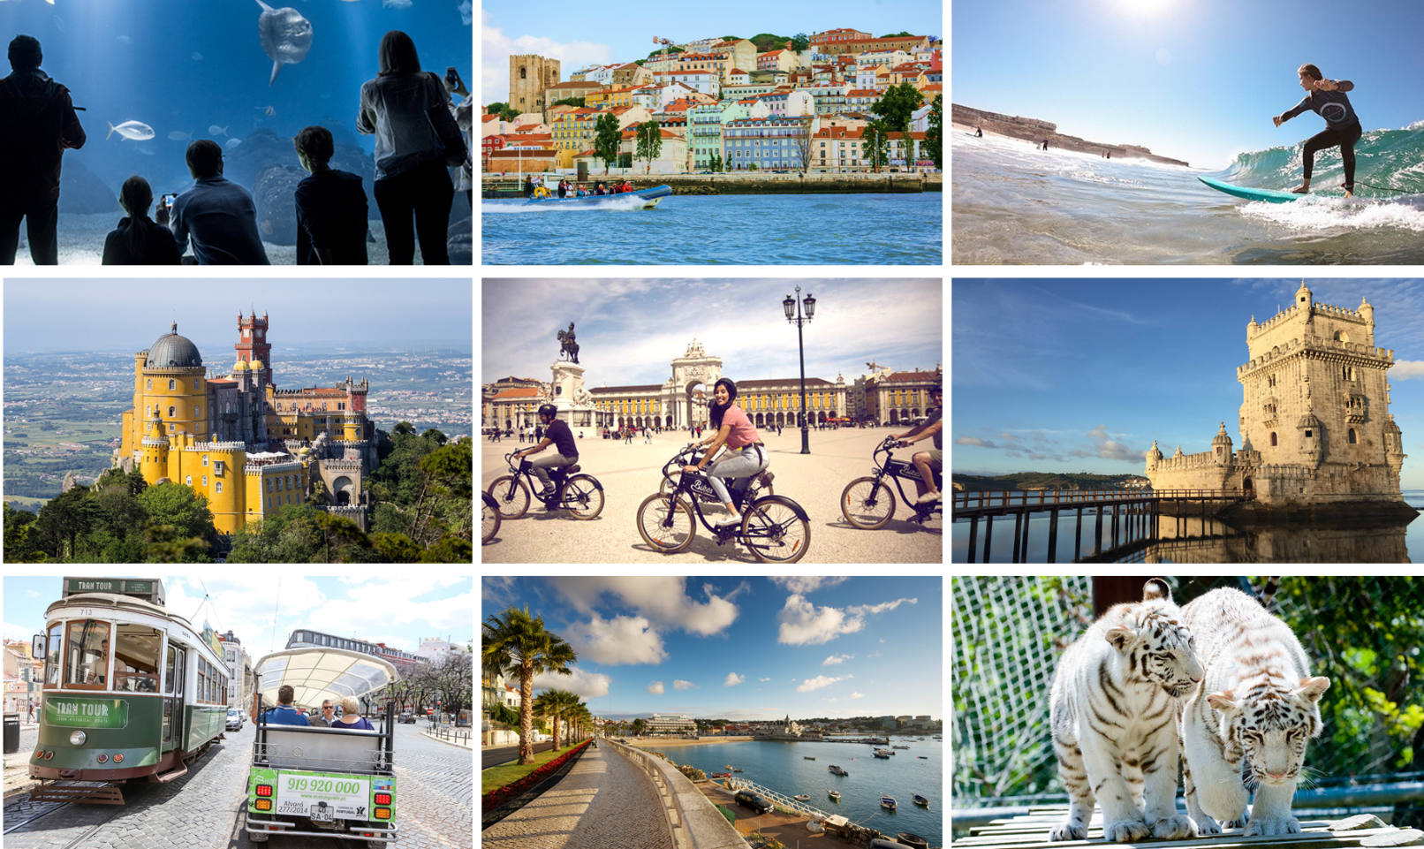

Portugal – Lifestyle Individual Incentive Travel – Family Adventure

Fall in love with Portugal and rediscover the rewards of family travel on this carefully crafted itinerary designed with both you and your kids in mind. On this seven-day adventure in Lisbon and its Coastal Line, you and your family will get to explore the typical Lisbon’s cobbled lanes, charming towns such as Sintra and Obidos, as well as tasting your way around the best of Portuguese cuisine.
As a sun-drenched country facing the Atlantic Ocean, you will have the opportunity to sit back and relax on the beach while the youngsters dive on a Surf class.
Other kids-friendly activities such as a boat ride on the stunning Tagus River, a visit to the amazingly diverse Oceanarium and a fun Tuk Tuk ride along Lisbon city were included as a form of combining the best Lisbon and its coast have to offer culture wise with an entertaining and relaxed time for the whole family!
With all the logistics and essential experiences taken care of, treat yourself to some family time on this Portuguese adventure and make wonderful memories with your loved ones!

Program Inclusions for up to 4 people

VIP Meet & Greet at Lisbon International Airport
Priority Passage at Passport Control
Early Check in
Welcome gift
Private driver/guide throughout
All ground transportation
Deluxe hotel accommodation, based on double occupancy:
- 6 nights in Lisbon Coastal Line – Onyria Quinta da Marinha Hotel or similar
Daily Breakfast
Private Fun Tuk Tuk And Bike Lisbon tour
Belém Quarter Private Walking Tour
Private Boat Ride on Tagus River
Lisbon’s Zoo Entrance fee
Bounce – Free Jump Trampoline Arena Entrance Fee
Sintra Private Tour
Sintra National Palace Entrance fee
Surf Class or Sailing Class
Medieval Town of Obidos Private Tour
Chery liquor tasting
Aquarium Entrance fee
Golf Class at Quinta da Marinha
4 Lunches per person at local restaurants
4 Dinners per person at local restaurants
Farewell gift

Day by day (internal info)

Day 1
VIP Meet & Greet at Lisbon International Airport | Access to VIP lounge / escort through the arrival process
Priority Passage at Passport Control
Private transfer pick up at the airport – drop off at the Quinta da Marinha Hotel or similar
Early Check in
Welcome gift
Morning: at leisure
Lunch: at leisure
Afternoon: Estoril and Cascais Village Panoramic Tour
Evening: Early Dinner at the hotel

Day 2
Morning: Exploring Lisbon by tuk tuk (main sites such as Estrela, Castle, Miradouro, Baixa, Commercial Square, etc)
Lunch: Museu da cerveja/ Café do Rio – Hamburgueria Gourmet/ Baía do Peixe or similar
Bike ride from Praça do Comercio until Belém
Afternoon: Belem walking tour + boat trip until Cascais
Evening: Dinner at Cantinho do Avillez Cascais or similar

Day 3
Morning: Jardim Zoologico de Lisboa - Founded in 1884, the Lisbon Zoo was the first park with fauna and flora in the Iberian Peninsula. With the many consignments of animals from Africa and Brazil the Zoo has become one of the largest and most diverse zoos in the world and it takes an active role in the protection and conservation of Nature.There live around 2000 animals in a group of approximately 300 species, including mammals, birds, reptiles and amphibians.
Lunch: Sete Mares or similar (close to the Zoo; apart from great seafood, it has typical portugueses dishes as well as kids menus)
Afternoon: Bounce or similar activity (karts / Workshop / Museum/ Pav. Conhecimento)
Evening: Dinner at Pap’Açorda / 1300 Taberna /similar

Day 4
Morning: Magical Sintra and the Town Palace
Almoço: Café Central / Farta Pão | similar
Afternoon: Cabo da Roca and Guincho – surf class
Evening: Dinner at Hifen Cascais or similar

Day 5
Day trip to Óbidos – The Medieval Town, located at about 1h00/1h15 from Lisbon, remains a well-preserved example of medieval architecture with traces from 12th century onwards.
Lunch at Sanguinhal Wine Estate
Evening: Dinner at leisure

Restaurant recommendations and additional activities to be provided on request
Day 6
Morning: Lisbon Oceanarium – The Lisbon Oceanarium is a marine biology museum located in the Park of Nations Lisbon, Portugal, built for the Expo 98. This pavilion, designed by the American architect Peter Chermayeff, reminiscent of an aircraft carrier. It is the second largest oceanarium in Europe and contains an impressive collection of species of birds, mammals, fish and other marine inhabitants. It consists of four separate areas representing the habitats of the Atlantic, Pacific, Indian and Antarctic wildlife and oceans.
Shopping opportunity at Centro Comercial Vasco da Gama
Afternoon: at leisure (eg: pool, beach, spa, etc)
Optional Afternoon Activity: golf class
Evening: Farewell dinner at Reserva da Villa or Similar
Farewell gift drop off

Restaurant recommendations and additional activities to be provided on request

Day 7

Departure: Private transfer pick up at the Hotel – drop off at Lisbon airport

Welcome and Farewell gift suggestions for the children
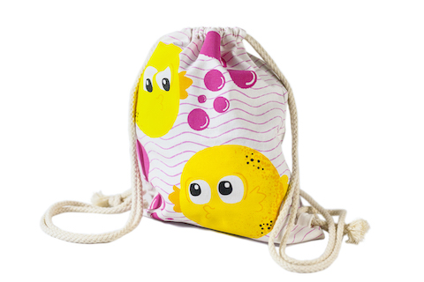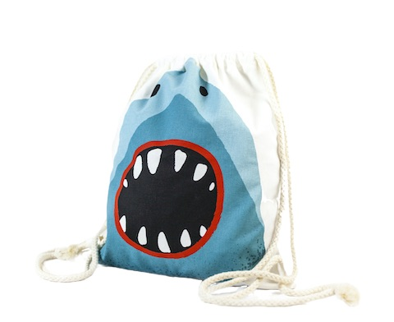
Lisbon’s Oceanarium Puffer fish bag Lisbon’s Oceanarium Shark bag

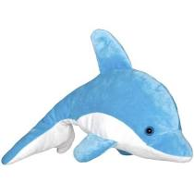
Stuffed animal from the Zoo (sample images)
Welcome and Farewell gift suggestions for the adults

1 ceramic piece Portuguese Sardine, by Bordallo Pinheiro - Examples:

“Vista Alegre” Portuguese Porcelain |Coffee OR Tea Cup and plate (sample images)

Cork Coin Pouch and Cork Card Holder
