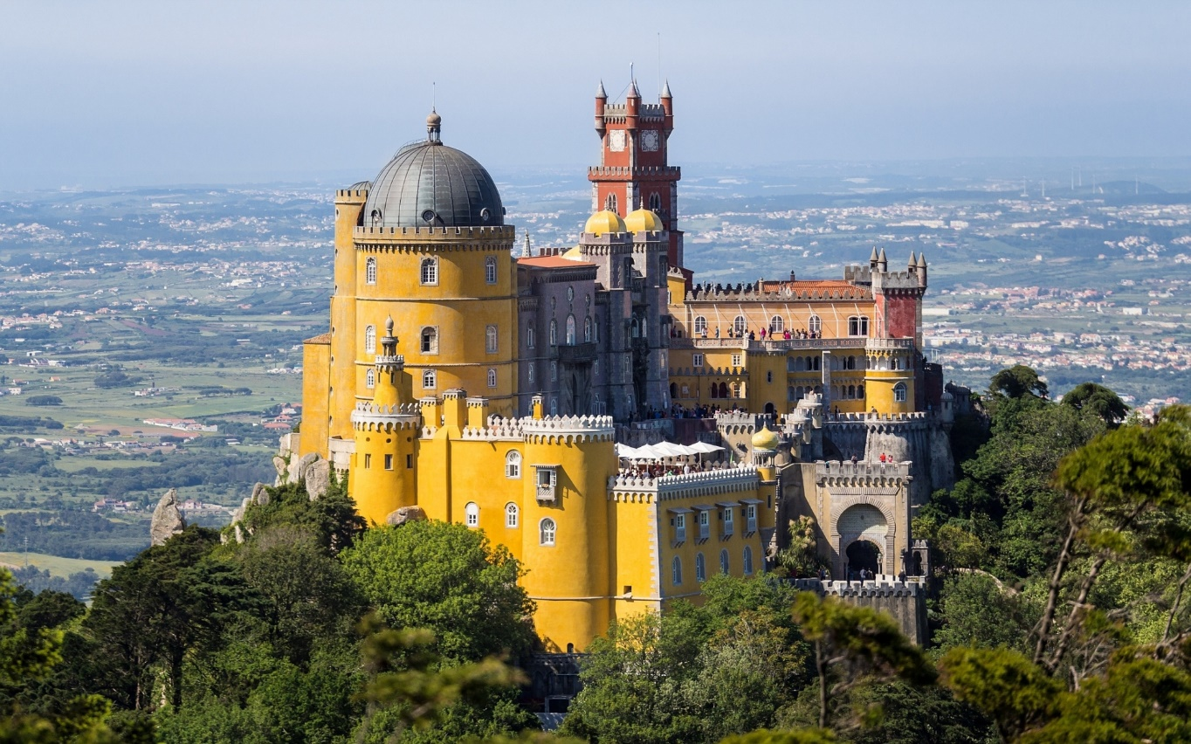

Portugal – Lifestyle Individual Incentive Travel – Arts and Culture
Lisbon – Arts and Culture

Program Overview
Lisbon is as much about heritage and historic sights, as it is about trends, art and culture.
Experience the old, the new and everything in between! See the city of Lisbon in the most exclusive way. One experience at a time, guests will travel back and forth through the centuries to embrace Portuguese culture and heritage.

A highlight will be the final night as guests travel back in time to the 18th century with a once-in-a-lifetime themed dinner at the Fronteira Palace - one of the most beautiful seventeenth century Palaces in Lisbon and home to the largest collection of 17th century “azulejos” (Portuguese tiles). It is also the actual home of the descendants of Dom João de Mascarenhas, the first Marquis of Fronteira. This evening includes a classic car transfer, a welcome to the Palace by a Marquis family member and a wonderful dinner with fully costumed waiters and entertainment by a string quartet.

Program Inclusions for Two
- VIP Meet & Greet at Lisbon International Airport
- Expedited clearance through immigration and passport control
- Guaranteed early check-in at the Hotel
- Personalized welcome letter signed by the Marquis of Pombal – who led Portugal's recovery from the 1755 Lisbon earthquake and modernized the kingdom's administrative, economic, and ecclesiastical institutions
- Welcome & Farewell gifts
- Private driver/guide throughout
- All ground transportation
- Deluxe hotel accommodations, based on double occupancy:
- 5 nights in Lisbon – Bairro Alto Hotel (or similar) with breakfast daily
- Private city tour of the highlights of Lisbon to get an overview of the rich culture and history
- Portuguese gastronomy & delicacies tastings:
- World famous Pasteis de Belém, custard tarts
- Sintra Travesseiros & Queijadas
- Ginja, a Cherry liqueur
- Wine tasting at the Sanguinhal Wine State
- Visit to the Calouste Gulbenkian and the National Ancient Art Museums
- Visit and free time to shop at our trendy and coolest markets Time Out and LX Factory
- Private old tram with a Portuguese guitar player and a Fado singer
- Hands-on immersion in a traditional Portuguese arts and crafts with a workshop at the Museum of Decorative Arts
- Private visit the Pena Palace, one of Portugal's most visited monuments and the favorite in Sintra. Discover the Palace surroundings and the magic of Sintra on a romantic carriage tour
- Visit the westernmost point of mainland Portugal, of continental Europe, and of the Eurasian land mass – Roca Cape and explore Lisbon’s coastline Guincho and Cascais
- Tour Óbidos - a mediaeval town that is one of the most picturesque and well preserved in Portugal
- Explore Lisbon’s historical quarters & streets with a fashion advisory while shopping on the finest stores selling both luxurious fashion designs and typical Portuguese products, such as Luís Onofre, Rosa & Teixeira, Vista Alegre, Cork & CO, Benamôr, Jewellers Torres and many others
- Final night dinner once-in-a-lifetime dinner at Fronteira Palace

Day-by Day Program
Day 1 – Welcome to Lisbon
Arrival | VIP Meet & Greet at Lisbon International Airport
- Upon arrival at Lisbon Airport your will be met at the aircraft by a hostess of the Airport VIP Services and be accompanied through the priority passport control and luggage pick up until the arrivals hall, where a PTT Representative​ will escort you until the your private transfer
Private transfer from Lisbon APT to Hotel
Guaranteed early check-in at the Hotel
At the Hotel room, upon arrival:
- Personalized welcome letter signed by the Marquis of Pombal – who led Portugal's recovery from the 1755 Lisbon earthquake and modernized the kingdom's administrative, economic, and ecclesiastical institutions
- Welcome gift - book Lisboa, by Fernando Pessoa
Afternoon | Welcome to Lisbon tour (panoramic city highlights by private car, vintage beetle or tuk-tuk) towards Belem with a tasting of the world-famous custard tarts – Pasteis de Belém
Dinner | Early dinner at the Hotel Restaurant

Day 2 – Cultural Lisbon | Old & New
Morning | Visit the Calouste Gulbenkian Museum and the National Museum of Ancient Art
Lunch | Pap’Açorda Restaurant (or similar) & Time Out Market
Afternoon | Private Tram ride with a Portuguese guitar and a Fado singer onboard, a luxurious experience that will lead you until the Museum of Decorative Arts
- Visit the museum and enjoy an exclusive and very special 2-hour workshop. Choose one of the traditional Portuguese arts and crafts that keep alive our heritage - tile painting, marbled paper, leather engraving, gilded, trimmings or decorative paintings
Dinner | 1300 Taberna (or similar) & Lx Factory

Day 3 – Magical Sintra & Cascais
Morning | Private visit to Pena Palace & Sintra village tour by carriages – Taste the Sintra delicacies Travesseiro and Queijada
Lunch | not included – at leisure
Afternoon | Private tour to Roca Cape, Guincho and Cascais (walking tour through Cascais city center)
- To celebrate the visit to Cabo da Roca, our Henry the Navigator (actor fully costumed) will welcome you with sparkling wine flutes and present you with personalized diplomas
Dinner | Porto Santa Maria Restaurant (or similar)
Day 4 - Medieval Óbidos
Morning | Experience Lisbon views and the Portuguese western coast on a private helicopter tour until Óbidos
Discover our mediaeval town of Óbidos and taste Ginja – our Cherry liqueur (walking tour through the village)
Lunch | Sanguinhal Wine Estate with a private wine tasting and lunch
Afternoon | at leisure
Dinner | Travessa Restaurant (or similar)

Day 5 – Made in Portugal | Exclusive travel to the 18th century
Morning | Exclusive tailor-made shopping tour accompanied by a private fashion advisor - Made in Portugal | Choose and visit the Portuguese finest:
- Fashion Designers Filipe Faísca, Alexandra Moura, Nuno Gama, Luís Onofre, Rosa & Teixeira
- Portuguese products Vista Alegre Atlantis, Garrafeira Nacional, Burel Chiado, Cork & CO, Benamôr
- ewellers Torres Joalheiros, Joalharia do Carmo
You can also add international luxury brands on your shopping tour such as Fashion Clinic, Prada, Michael Kors, Burberry, Emporio Armani, Miu Miu, Ermenegildo Zegna, Karen Millen, Zadig & Voltaire, Louis Vuitton, and more.
Lunch | not included – at leisure
Afternoon | continue shopping or at leisure
Dinner | Farewell themed Dinner at the Fronteira Palace, an exclusive travel to the 18th century! Includes:
- A private transfer by the old timers
- Meet & greet by a Marquis family member upon arrival at the Palace
- Dinner with 18th century décor and fully dressed waiters
- A strings quartet to accompany the dinner and set the mood

The Fronteira Palace
Is one of the most beautiful seventeenth-century Palaces in Lisbon. It holds the largest collection of seventeenth century “azulejos” (Portuguese tiles) preserved in situ. It was built around 1670 and was used as a second residence and hunting lodge by the Mascarenhas family before the Lisbon earthquake. The family moved in 1755, after their main downtown residence was destroyed in the disaster.
Although we live in a democracy, we still have members of royalty.
Classified as a national monument, it is also the current home of the descendants of Dom João de Mascarenhas. This is one of the many charms of the place, giving it a human touch and contributing to its special atmosphere.

Farewell gift in room – 1 ceramic piece Portuguese Sardine, by Bordallo Pinheiro
The sardine was crowned "queen" of the popular festivities in the capital, therefore it was immortalized in ceramics in the artistic legacy left by Raphael Bordallo Pinheiro.

Day 6 – Farewell
Departure | Private transfer to Lisbon APT

Welcome Gift – 1 book Lisboa, by Fernando Pessoa
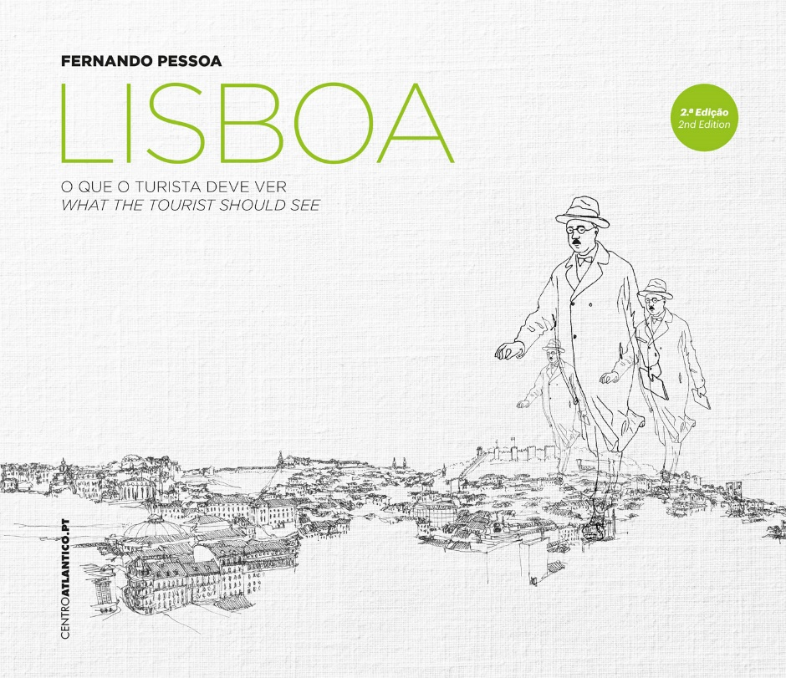

Farewell Gift – 1 ceramic piece Portuguese Sardine, by Bordallo Pinheiro
Examples:

