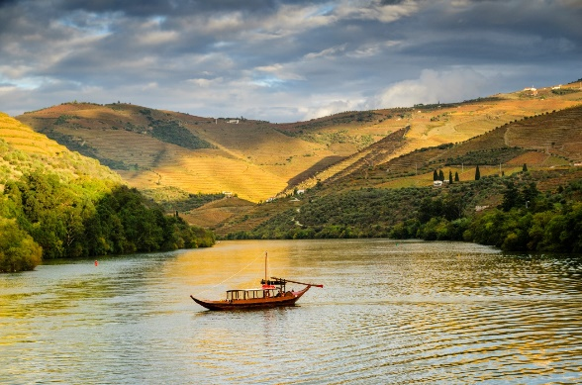
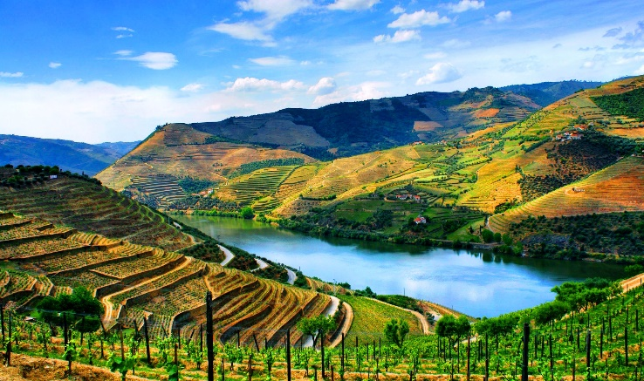
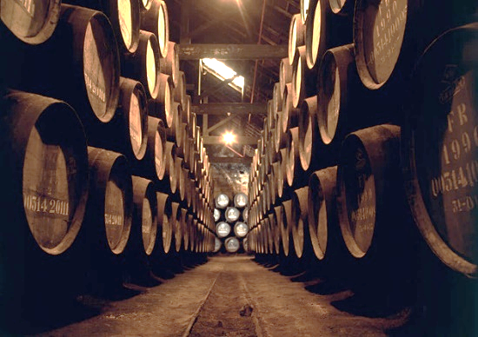
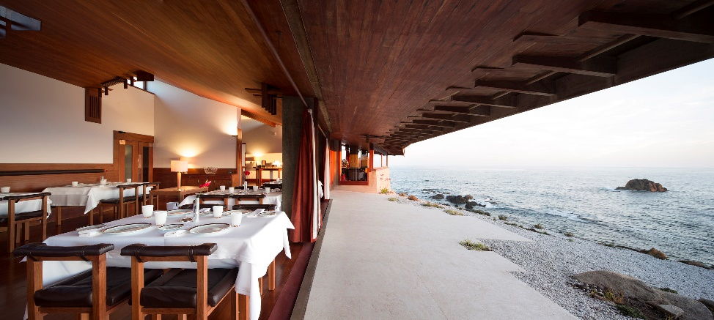
Portugal – Lifestyle Individual Incentive Travel – Food and Wine

Program Overview
In Portugal the gastronomy and the wine production are intimately connected with the country’s history and traditions. Each region offers different overviews and has developed their own way of creating their products and heritage, but all have one thing in common – the compromise to offer the best quality in all that is produced!
This program in the north of Portugal invites you to visit the traditional food markets in the Porto costal region, to experience the contemporary food of the Michelin star restaurants and visit the most exclusive wine cellars and estates, while feeling the magical wonders of the Douro Valley, where the wine, the food and the river don’t live without one another.

Program Inclusions for Two
VIP Meet & Greet at Porto International Airport
Priority passport control
Early check-in at the hotel guaranteed
Welcome gift and Farewell gift
Private driver/guide throughout
All ground transportation
Deluxe hotel accommodations, based on double occupancy:
- 2 nights in Porto – The Yeatman Hotel
- 1 night in Amarante – Casa da Calçada
- 2 nights in Douro Region – Quinta da Pacheca, Wine House Hotel
- 1 night in Porto
Breakfast daily
Private Porto Panoramic Delicacies tour by tuk-tuk
Private Local market visit and cooking class
Private visit to the Port Wine Cellars and tasting
Luxury Dinners at Michelin star restaurants in Porto and Amarante
Private walking tour of the historical Amarante Town
Private Wine Estate Visit and Tasting in Douro Region
Private Walking Tour of Peso da Régua
Private boat tour along the Douro Valley
Jeep tour with stops at Pinhão and the most impressive viewpoints
Gastronomic Dinners in the Douro Region

Day-by Day Program:
Day 1
- VIP Meet & Greet – Access to VIP lounge / fully escorted through the arrival process
- Priority passport control
- Early check-in at the Hotel
- Welcome gift – Vista Alegre – Alma do Porto ceramic plate
- Private transfer from Porto APT to The Yeatman Hotel
- Afternoon | Private Porto Panoramic Delicacies tour by tuk-tuk
- Evening | Early dinner at the Hotel Restaurant

Day 2
- Morning | Local market tour and Cooking Class (lunch included)
- Afternoon | Private visit to the Graham’s Wine Cellar and tasting
- Dinner | Casa de Chá da Boa Nova Restaurant (2 Michelin Star)

Day 3
- Depart to Amarante
- Private walking tour of the ancient town centre, S. Gonçalo church and Convent, cross the medieval bridge and taste the typical S. Gonçalo sweets.
- Dinner | Largo do Paço Restaurant (1 Michelin star)

Day 4
- Depart towards the Douro Region
- Private visit the Wine Estate followed by private wine tasting and lunch at the Hotel Restaurant
- Afternoon | Walking tour of Peso da Régua – visit to the Douro Museu (History of the Douro Region and Wine) and Régua Sweets tasting
- Dinner | Castas e Pratos Restaurant

Day 5
- Visit the of the Douro Region by Jeep:
  - Pinhão – town private walking tour
  - Private Boat cruise to Pinhão and Romaneira with stop in Pinhão
  - Guided tour of Pinhão town
  - Lunch | Quinta de La Rosa – Cozinha da Clara Restaurant
  - Afternoon | Jeep ride to the most emblematic viewpoints – Casal de Loivos (Pinhão) and S. Leonardo da Galafura (Régua)
  - Dinner | DOC Restaurant

Day 6
- Depart to Porto
- Day at leisure
- Farewell Gift – Port Wine
Restaurant recommendations and additional activities to be provided on request

Day 7
- Departure | Private transfer to Porto APT

Welcome Gift – Vista Alegre Ceramic Plate – Alma do Porto
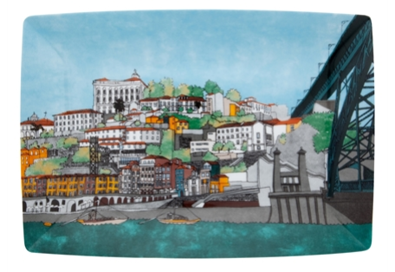

Farewell Gift – Port Wine Bottle – 20 year old Tawny

